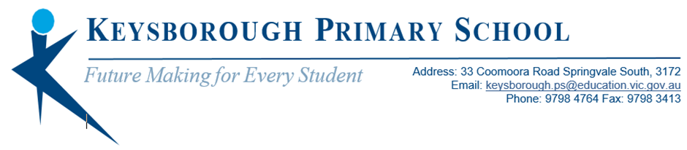

PREP PARENT INFORMATION SESSION
2022

The Prep Team at Keysborough Primary School would like to invite you to join a parent information session regarding your child’s education and continuity of learning in 2022.

There will be two sessions available to choose from. You do not need to attend both as they will cover the same information.

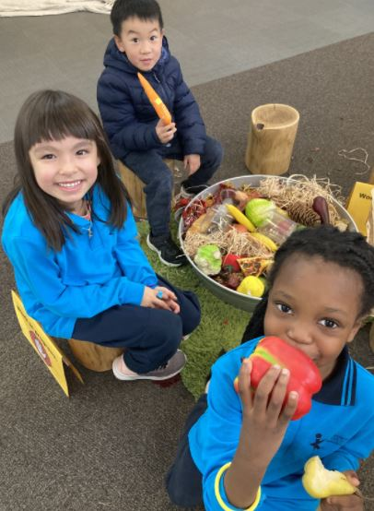
The information session will be conducted online using the WebEx video conferencing platform.
Please click on the following link to enter the session:
https://eduvic.webex.com/meet/mcdonald.briony.b1

Session dates and times:
- Thursday 26th August, 4.00-5.00pm
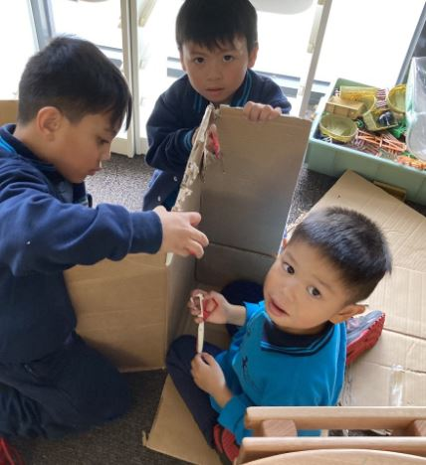
- Thursday 16th September, 4.00-5.00pm

Looking forward to seeing you there!

Kind regards,
Leanne Armao, Briony McDonald, Teghan Rooks, Rina Giacotto and Julie Nhem

